**HORMISDALLEN SCHOOL - KYEBANDO**

**PRE- PLE SET 8 EXAMINATIONS, 2023**

**PRIMARY SEVEN SCIENCE**

**Duration: 2 Hours 15 Minutes**

**NAME: ______________________________________________ STREAM: _________**

INDEX NO.

EMIS NO.

**SECTION A**

1., Name 'the human organ for 'ta,sting.

_____________________________________________________________________________________________

,2. Why is brushing, teeth a good health practice?

_____________________________________________________________________________________________

3. Write down one activity a. farmer can do in the wet season.

_____________________________________________________________________________________________

4. How does bush burning cause soil erosion?

_____________________________________________________________________________________________

5. State *any* one danger of improper use of a toilet

_____________________________________________________________________________________________

6. Point out any one sign of marasmus in infants.

_____________________________________________________________________________________________

7. Give any activity done to protect cattle from ecto parasites like ticks.

_____________________________________________________________________________________________

*8* How is the function of a fuse similar to that of a switch in an electric circuit?

_____________________________________________________________________________________________

9. l,n one word, write the name given to, animals without backbones.

_____________________________________________________________________________________________

**The diagram below is of a musical instrument. Use it to answer questions 10 and 11.**

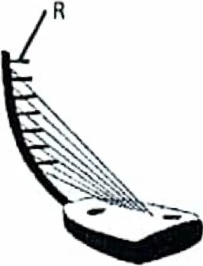

10. Name the part marked with letter R.

_____________________________________________________________________________________________

11. How can Moses change the pitch of the instrument above?

_____________________________________________________________________________________________

12 In which way is a, human kidney and the skin similar in function?

_____________________________________________________________________________________________

1, 3. Why, is soil erosion considered as a physical change?

_____________________________________________________________________________________________

1,4. Name the type of dige,stion in which the teeth break down food into small particles.

_____________________________________________________________________________________________

15~ How do plants reduce the· amount of' carbon dioxide in the atmosphere?

_____________________________________________________________________________________________

16. Give the typ,e of electricity produced when a plastic pen is rubbed on the hair.

_____________________________________________________________________________________________

17. In one sentence, write do1wn the m1ea.ning of castration.

_____________________________________________________________________________________________

18. How is the· hepatic portal vein useful in the body?

_____________________________________________________________________________________________

19. Name the factor in a flower which attracts insect pollinators at night.

_____________________________________________________________________________________________

**The dia.gram below is of a simple machine. Use it to answer question ..**

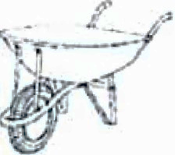

.20. Use, Jetter **L** and an arrow to show the position o·f ·the “load”

2·11. What type of energy is possessed by a ball placed at a penalty spot?

_____________________________________________________________________________________________

22. Why does clay soil remain water logged than sandy soil?

_____________________________________________________________________________________________

**2.3. In the space below. draw a concave lens.**

24. How can a farmer make use of c·ow dung to control deforestation?

_____________________________________________________________________________________________

25. Name the non-living resource which supports life of a silver fish.

_____________________________________________________________________________________________

26. Why should garden tools be cleaned every after use?

_____________________________________________________________________________________________

27. Name the part of the body where respiration takes place.

_____________________________________________________________________________________________

2..8. Mention one way a magnet can lose its magnetism ..

_____________________________________________________________________________________________

29 Why is the earth called a natural magnet'?

_____________________________________________________________________________________________

30. Name any one plant that stores its food in the· stem.

_____________________________________________________________________________________________

31. Give one factor that determines the size of an image in a pin hole camera.

_____________________________________________________________________________________________

32. Which component of air is a bi-product of photosynthesis?

_____________________________________________________________________________________________

**The diagram below is of a simple complete electric circuit. Use it to answer question 33.**

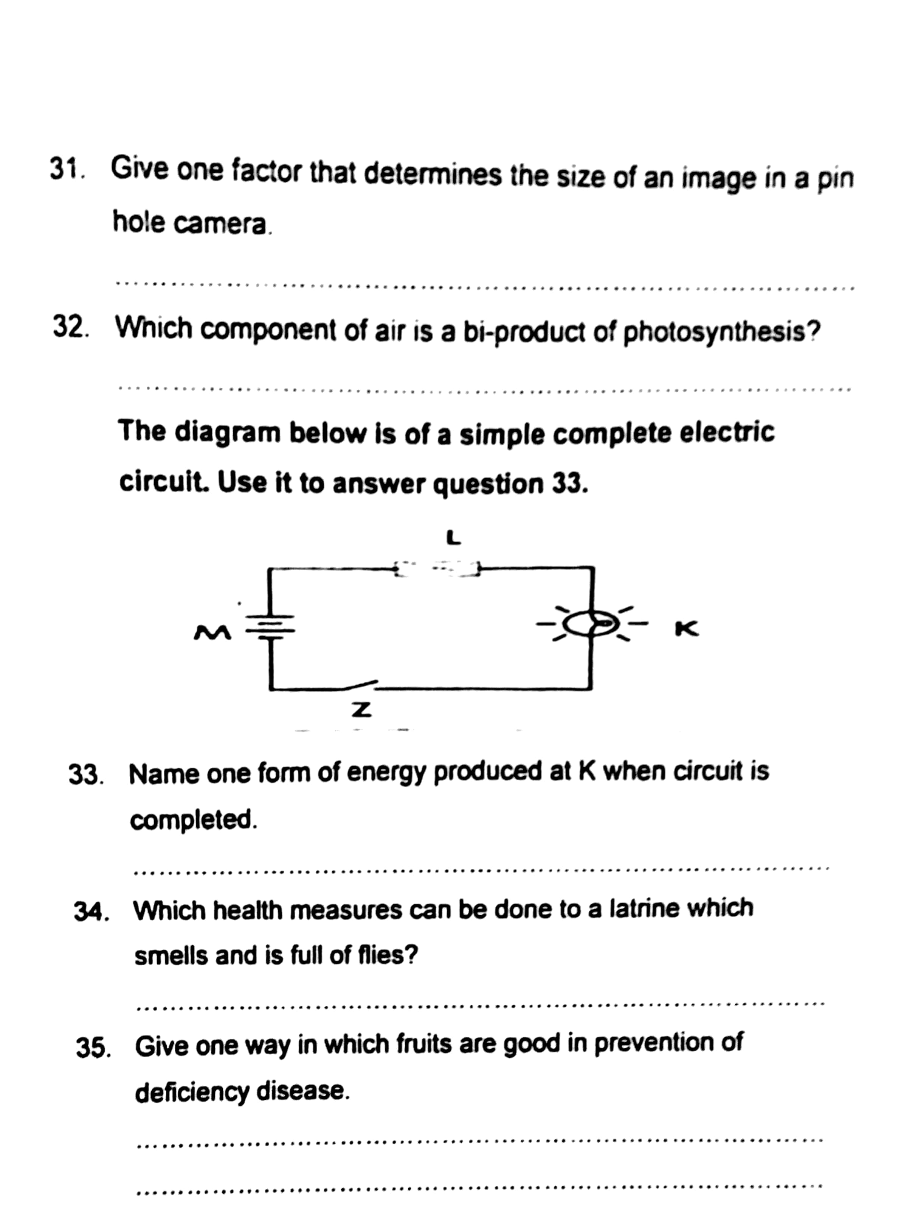

33. Name one form of energy produced at K when circuit is completed.

_____________________________________________________________________________________________

34. Which health measures can be done to a latrine which smells and is full of flies?

_____________________________________________________________________________________________

35. Give one way in which fruits are good in prevention of deficiency disease.

_____________________________________________________________________________________________

**The diagram below· is of a method of magnetization. Use It to answer question number 36,**

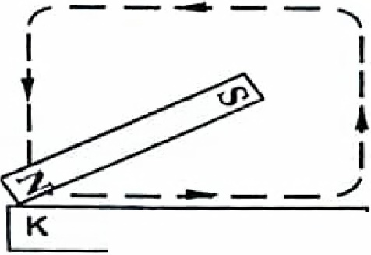

**and 37.**

36.. Identify the method shown above.

_____________________________________________________________________________________________

37. What pole will be formed at K.?

_____________________________________________________________________________________________

38. M:ention one danger of sharing a drug with another patient

_____________________________________________________________________________________________

39,_ Apart from controlling erosion, give one other reason why mulching is important.

_____________________________________________________________________________________________

40. Name the major way through which AIDS virus is spread

_____________________________________________________________________________________________

**SECTI0N B**

,41. (a) Name one vaccine used to immunize children against tuberculosis.

_____________________________________________________________________________________________

(b) Give the reason why the measl1es vaccine is ,administered at 9 months, but. not at birth.

_____________________________________________________________________________________________

(c) Why is immunization an important health activity among children?

_____________________________________________________________________________________________

(d) State any other way children's immunity is boosted.

_____________________________________________________________________________________________

42,. (a)Give any two methods of making alcohol.

1. ____________________________________________________________________________________
2. ____________________________________________________________________________________

b ). S'tat1e any one scientific value of alcohol in the society.

_____________________________________________________________________________________________

c). Give any one health effect o,f alcohol to an individual.

_____________________________________________________________________________________________

43. a) Give any other state of matter apart from liquid.

_____________________________________________________________________________________________

b)i. State two reasons why we g1ive first aid to casualties.

(i) _____________________________________________________________________________________________

(ii) _____________________________________________________________________________________________

c), How is la burn different from a scald?

_____________________________________________________________________________________________

44,. **The list below shows ·two groups of invertebrates shown above.**

**A B**

**Spider housefly**

**Tick Tsetse fly**

**Mite Cockroach**

**Scorpions Mosquito**

45. ldentify the groups of arthropods shown ,above, ..

_____________________________________________________________________________________________

b) How is reproduction of la tsetse fly in group B di1fferent from the rest?.?

_____________________________________________________________________________________________

c) State any one use of the tracheal system to some organisms in A.

_______________________________________________________________________________

46. (a) Give· the· meaning ,of t.he following words as used in the study of sound.

(i) Pitch ______________________________________________________________________________________

(ii) Frequency _________________________________________________________________________________

(iii) Volume ___________________________________________________________________________________

(b). How does a drum produce sound?'

_____________________________________________________________________________________________

47 .. (a) How do organisms such as mushrooms reproduce?

_____________________________________________________________________________________________

(b) Give one similarity between a bacteria and a fungi.

______________________________________________________________________

_____________________________________________________________________

(c)Apart from mushrooms, give any other two examples of a fungi.

(i) __________________________________________________________________________

(ii) __________________________________________________________________________

**48. The diiagram below shows one of the processes in plants.**

**Use it to answer the questions that follow.**

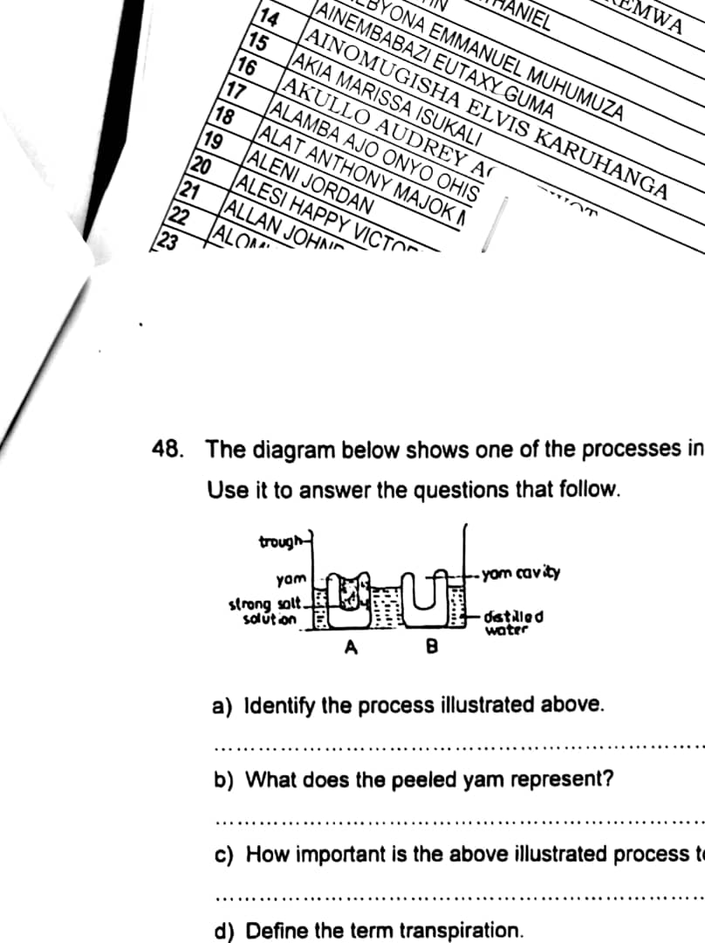

1. Identify the process illustrated above.

_____________________________________________________________________________________________

b) What does the peeled yam represent?

_____________________________________________________________________________________________

c) How important .is the above illlustrated process to plants?

_____________________________________________________________________________________________

d) Define the term transpiration.

_____________________________________________________________________________________________

49. a) Give ,any two disease vectors. whose life cycle passes through water.

(i) _____________________________________________________________________________________________

(ii) _____________________________________________________________________________________________

b). State any two diseases caused by poor sanitation in an area.

(i) _____________________________________________________________________________________________

(ii) _____________________________________________________________________________________________

50. Use the table below to answer question 48,.

|  |  |  |
| --- | --- | --- |
| **FOOD VALUE** | **SOURCE** | **DEFICIENCY** |
|  | Beans | Kwashiorkor |
| Vitamin C | Oranges |  |
| Carbohydrates |  | Marasmus |
|  | Carrots | Night blindness |

51. The diagram bellow is of kidn1e·y. Use it to .answer th1e questions tha·t follow.

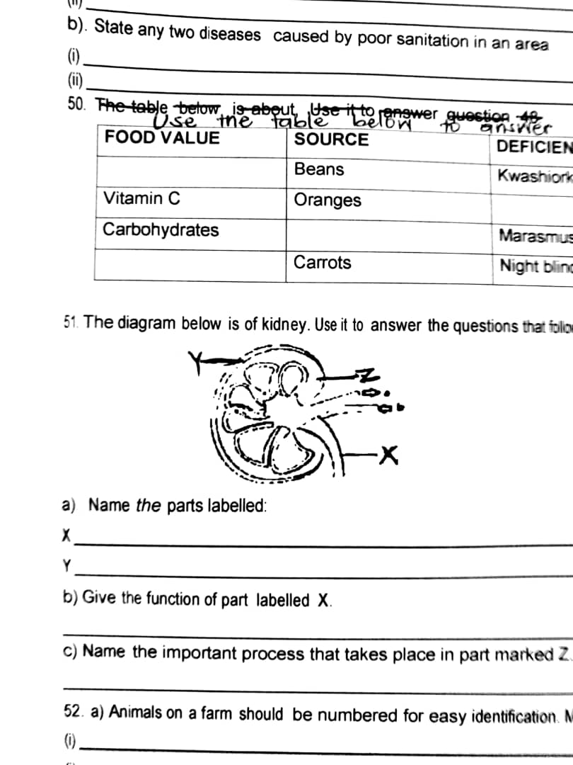

a) .. N1ame *the* parts labelled:

X ____________________________________________________________________________________________

Y ____________________________________________________________________________________________

b) Give ·the ·function of part labelled X.

_____________________________________________________________________________________________

c) Name, the important process that takes place in part marked Z. _____________________________________________________________________________________________

52. a) Animals on a farm should be numbered for easy identification. Mention ,any 'two wa.ys. this. is done .

(i) _____________________________________________________________________________________________

(i) _____________________________________________________________________________________________

b), 'Why should animals be castrated?

_____________________________________________________________________________________________

c), State any one way how castration is done.

_____________________________________________________________________________________________

**53. The diagram below is of an experiment about light**

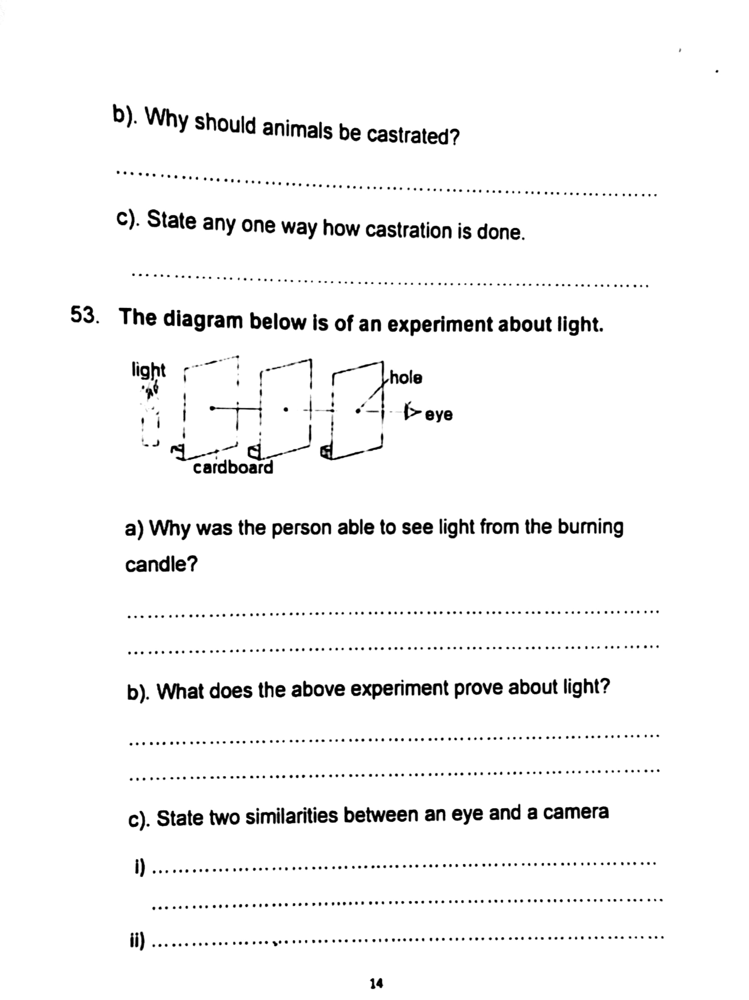

a) Why was the, person abl'e to .see light from the burning 1 candle?

_____________________________________________________________________________________________

b). What does the above experiment prove about light?

_____________________________________________________________________________________________

c) State two similarities between an eye and a camera

(i) ________________________________________________________________________

(ii) ________________________________________________________________________

54 a) Which germ causes AIDS?

_____________________________________________________________________________________________

b). Why is abstinence considered the best method for controlling AIDS among youth?

_____________________________________________________________________________________________

c), Apart from AIDS, give two other sexually transmitted diseases.

(i) _____________________________________________________________________________________________

(ii) ____________________________________________________________________________________________

.5·5. a) Name the type of blood found in the following blood vessels. .

(i) Vena cava ___________________________________________________________________________________

(ii)Pulmonary vein ___________________________________________________________________

b), How are the valves useful1 in the human heart:?

_____________________________________________________________________________________________

_____________________________________________________________________________________________

c), Name the component of blood that carries oxygen around the body.

_____________________________________________________________________________________________